**CRM OF APPLICATION FOR JEWEL**

**MANAGEMENT (DEVELOPER)**

**COLLEGE NAME: SREE NARAYANA GURU COLLEGE , KG CHAVADI COIMBATORE**

College Code: bru36

Team ID: NM2025TMID26535

TEAM MEMBERS 5

TEAM LEADER : MRIDHULA R

Email ID : [mridhulamridhularajan@gmail.com](mailto:mridhulamridhularajan@gmail.com)

TEAM MEMBER 1 : SANGEETH KRISHNAN JS

Email ID : [sangeethkrsh@gmail.com](mailto:sangeethkrsh@gmail.com)

TEAM MEMBER 2 : ROHINI S

Email ID : [rohinirohhu263@gmail.com](mailto:rohinirohhu263@gmail.com)

TEAM MEMBER 3 : SANJEEV S

Email ID : [sanjeevsurendran8903@gmail.com](mailto:sanjeevsurendran8903@gmail.com)

TEAM MEMBER 4 : RESHMA D

Email ID : [reshma29072004@gmail.com](mailto:reshma29072004@gmail.com)

**1.1 INTRODUCTION**

In the highly competitive and customer-centric jewelry industry, managing customer relationships, inventory, sales, and services efficiently is critical for business growth and customer retention. This project aims to develop a **CRM application tailored specifically for jewelry management**, combining customer engagement tools with backend support for inventory and sales operations.

The CRM application will enable jewelry businesses to **track customer preferences, manage personalized communications, oversee purchase history, and schedule follow-ups for anniversaries, birthdays, or maintenance services**. Additionally, it will provide robust features for managing **inventory of gold, silver, diamonds, and gemstones**, along with sales tracking, repair orders, and supplier management.

**Creating Developer Account**

Creating a developer org in salesforce.

1. Go to <https://developer.salesforce.com/signup>
2. On the sign up form, enter the following details :

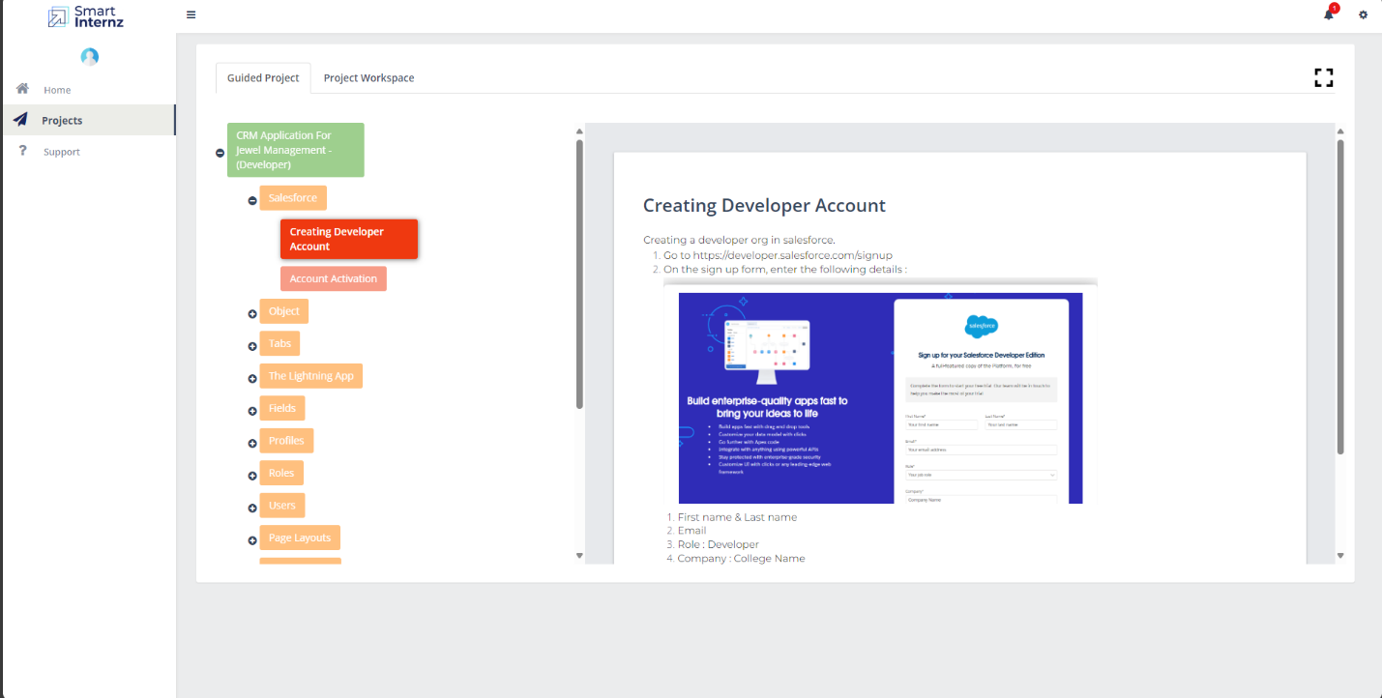

**Create Jewel Customer Object**

The purpose of creating a Jewel Customer custom object is to store and manage information about Customer.

To create an object:

1. From the setup page >> Click on Object Manager >> Click on Create >> Click on Custom Object.

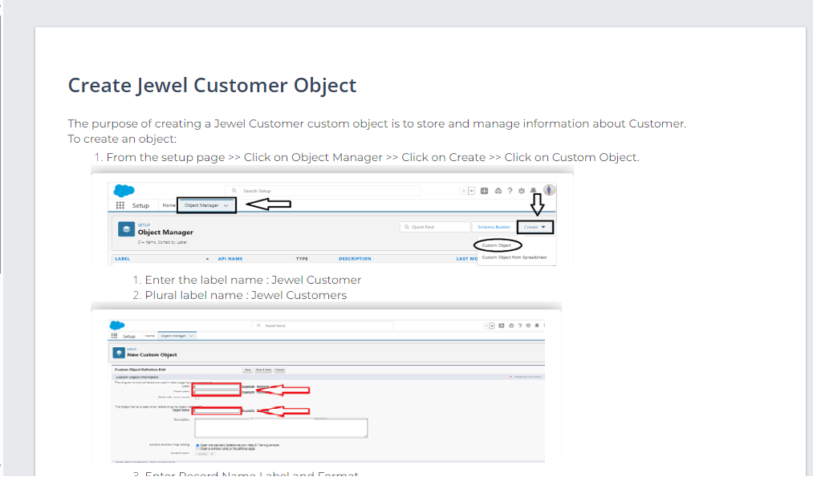

**Creating a Custom Tab**

To create a Tab:(Customer)

1. Go to setup page >> type Tabs in Quick Find bar >> click on tabs >> New (under custom object tab)

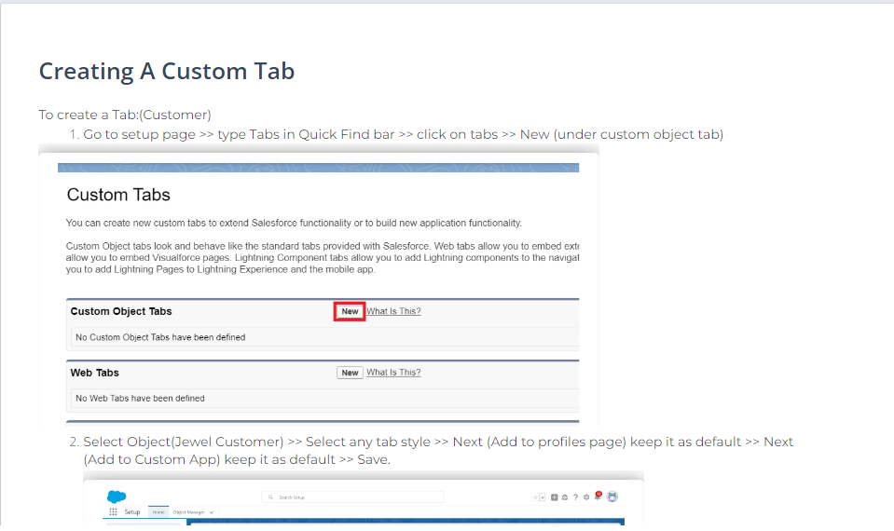

**Create a Lightning App**

To create a lightning app page:

1. Go to setup page >> search “app manager” in quick find >> select “app manager” >>

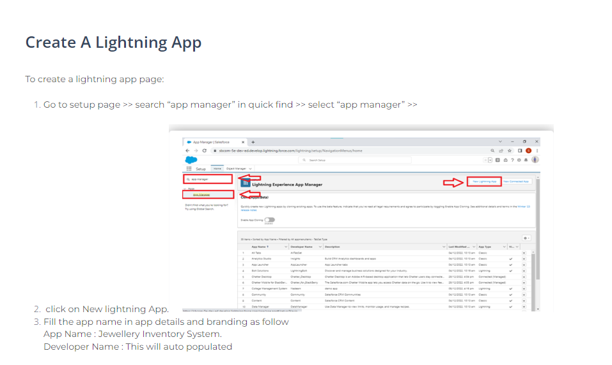

**Creating Text Field in Jewel Customer Object**

To create fields in an object:

1. Go to setup >> click on Object Manager >> type object name(Jewel Customer ) in quick find bar >> click on the object.

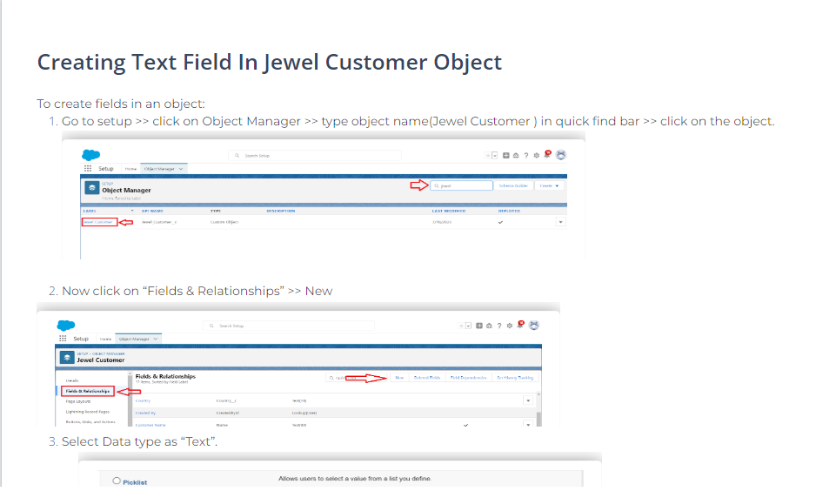

**To Create a Gold Page layout**

1. Go to Setup >> Click on Object Manager >> Search for the object (Item) >> From drop down click on Edit.
2. Click on Page layout >> Click on New.

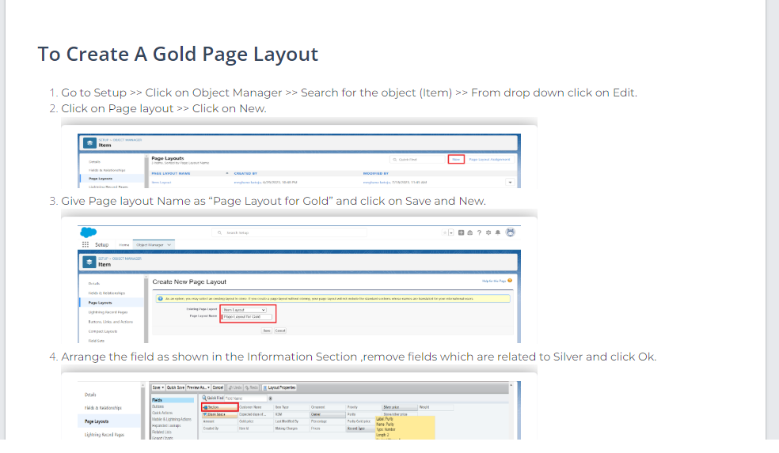

**Create Dashboard**

1. Go to the app >>  click on the Dashboards tabs.

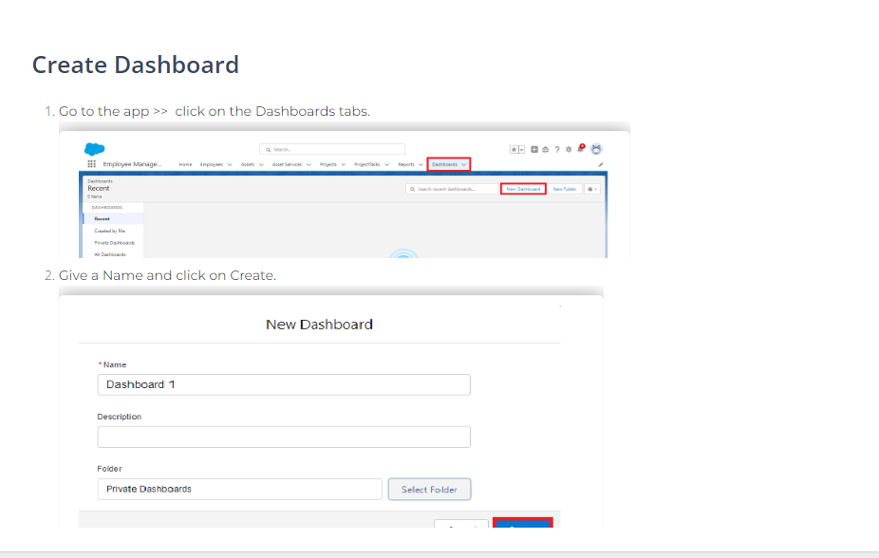

**Conclusion:**

The development of the CRM application for jewelry management marks a significant step toward modernizing and streamlining operations within the jewelry industry. By combining customer relationship tools with robust inventory and sales management features, the application addresses the unique challenges faced by jewelers — from handling high-value inventory to maintaining long-term customer engagement.

Through this solution, businesses can gain deeper insights into customer behavior, automate follow-ups, and provide personalized services that enhance customer loyalty. Simultaneously, it enables efficient tracking of stock, sales, and supplier interactions, ensuring smooth day-to-day operations.

In conclusion, the CRM application not only improves operational efficiency but also empowers jewelry businesses to deliver a superior customer experience — ultimately driving growth, trust, and long-term success.

**Advantages:**

1. **Enhanced Customer Relationships**
   * Tracks customer preferences, purchase history, and important dates (e.g. anniversaries, birthdays).
   * Enables personalized marketing and timely follow-ups, improving customer loyalty.
2. **Centralized Data Management**
   * Combines customer data, sales, and inventory in one platform.
   * Reduces redundancy and improves data accuracy.
3. **Inventory Control**
   * Helps manage and track high-value inventory like gold, diamonds, and gemstones.
   * Real-time updates help prevent overstocking or stockouts.
4. **Sales & Order Tracking**
   * Monitors transactions, repairs, custom orders, and deliveries.
   * Helps in identifying best-selling items and customer buying patterns.

**Disadvantages:**

1. **High Initial Cost**
   * Custom CRM systems can be expensive to develop and implement.
   * Small jewelers may find it hard to afford upfront costs.
2. **Training Requirements**
   * Staff may need time and training to adapt to the new system.
   * Resistance to change may slow adoption.
3. **Data Security Risks**
   * Sensitive customer and inventory data may be at risk if not properly secured.
   * Requires regular backups and cybersecurity measures.
4. **Maintenance & Updates**
   * The system requires ongoing maintenance, updates, and technical support.
   * Downtime during updates could affect business operations.
5. **Over-Reliance on Technology**